Fig. 1a, Balanus tintinnabulum, nat. size; small specimen. TAB. I
1b, Balanus tintinnabulum, rostrum, internal view of, large specimen, nat. size.
1c, 1d, Balanus tintinnabulum, scutum and tergum, internal views of, from recent specimens, the opercular valves not having been found fossil.
Fig. 2a, Balanus calceolus, engraved from a recent specimen, the single fossil having been injured during examination.
2b, 2c, Balanus calceolus, scutum and tergum, internal views.
2d, Spur of tergum, variety: all from recent specimens, the opercular valves not having been found fossil.
Fig. 3a, 3b, Balanus spongicola, scutum and tergum, external views.
3c, 3d, Balanus spongicola, scutum and tergum, internal views.
3e, Balanus spongicola, shell, enlarged from a recent specimen, the single fossil being young, and having been injured by examination.
Fig. 4a, Balanus concavus, shell (Coralline Crag specimen).
4b, Balanus concavus, internal view of part of the carina (to the left hand), of the carino-lateral compartment, and of part of the lateral compartment,
showing the raised borders (r) on the rostral sides of the sutures in the sheath (Italian Tertiary specimen).
4c, Balanus concavus, shell, var., with longitudinal ridges or ribs not prominent (Coralline Crag).
4d, Balanus concavus, smooth var. (Piedmont specimen).
4e, Balanus concavus, scutum, external view (Corraline Crag).
4f, Balanus concavus, internal view do.
4g, Balanus concavus, tergum, external view do.
4h, Balanus concavus, scutum, internal view (Maryland, U.S.).
4i, Balanus concavus, tergum, internal view do.
4k, Balanus concavus, external view do.
4l, Balanus concavus, scutum, external view (Portugal fossil, and recent).
4m, Balanus concavus, tergum, external view do. do.
4n, Balanus concavus, scutum, internal view do. do.
4o, Balanus concavus, tergum, external view, very large specimen (Turin).
4p, Balanus concavus, scutum, small portion, at the rostral corner, highly modified, very large specimen (Turin).
Fig. 5a, Balanus porcatus, shell, nat. size (Red Crag).
5b, Balanus porcatus, small portion of basal margin of wall, much enlarged.
5c, Balanus porcatus, portion of basal plate, much enlarged.
5d, 5e, 5f, 5g, Balanus porcatus, scutum and tergum, external and internal views; engraved from recent specimens, the opercular valves not having been positively found fossil.
Fig. 6a, Balanus crenatus, twice nat. size (Red Crag).
Fig. 7a, 7b, Balanus Hameri, scutum and tergum, external views engraved from Canada glacial specimens, the opercular valves not having been found in Great Britain.

TAB. I

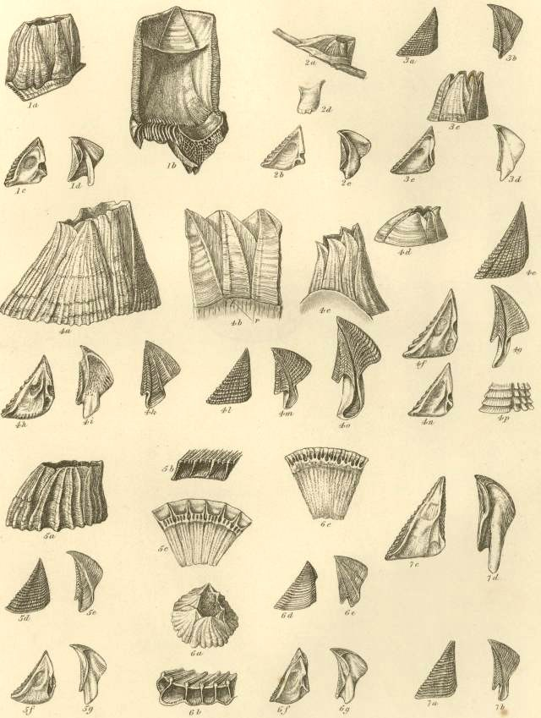

Fig. 1a, Balanus Hameri, lateral compartment, viewed externally. TAB. II
1b, Balanus Hameri, carino-lateral compartment, viewed internally.
Fig. 2a, Balanus bisulcatus, shell, 1½ nat. size.
2b, Balanus bisulcatus, rostrum, viewed externally, to show the commencement of the folding of the walls, 1½ nat. size.
2c, Balanus bisulcatus, var. plicatus, thrice nat. size.
2d, Balanus bisulcatus, very young shell, probably belonging to this species, enlarged about seven times.
2e, 2f, Balanus bisulcatus, scutum and tergum, external views.
2g, 2h, Balanus bisulcatus, scutum and tergum, internal views.
Fig. 3a, Balanus dolosus, rostrum, much enlarged, viewed internally.
3b, Balanus dolosus, portion of basal plate, much enlarged.
3c, 3d, Balanus dolosus, scutum and tergum, external views.
Fig. 4a, Balanus unguiformis, shell, twice nat. size.
4b, Balanus unguiformis, shell, var. erisma, twice nat. size.
4c, 4d, Balanus unguiformis, scutum and tergum, external views.
4e, 4f, Balanus unguiformis, internal views.
Fig. 5a, Balanus inclusus, shell, nearly thrice nat. size.
5b, Balanus inclusus, basis of shell, nearly thrice nat. size, showing basal edges of the compartments.
5c, Balanus inclusus, var., with its rostro-carinal axis elongated.
5d, Balanus inclusus, var., with its rostro-carinal axis elongated, showing the furrowed basis and lower portions of the six compartments.
5e, Balanus inclusus, var. intermediate between the last two varieties, basal view of, nearly twice nat. size.
5f, 5g, Balanus inclusus, scutum and tergum, internal views from a very young specimen.
Fig. 6a, Acasta undulata, rostrum viewed externally; spinose var.; twice nat. size.
6b, Acasta undulata, lateral compartment, smooth var., twice nat. size.
6c, Acasta undulata, basal cup.
6d, Acasta undulata, scutum, viewed internally.
6e, 6f, Acasta undulata, scutum and tergum, viewed externally.
Fig. 7a, Pyrgoma Anglicum, shell, viewed from above, four times nat. size.
7b, Pyrgoma Anglicum, scutum, internal view.
7c, Pyrgoma Anglicum, tergum, internal view, engraved from recent specimen, this valve not having been found fossil.
Fig. 8a, Coronula barbara, rostrum, external view; nat. size.
8b, Coronula barbara, rostrum, viewed internally; twice nat. size.
8c, Coronula barbara, lateral compartment, internal view.
8d, Coronula barbara, internal view, much enlarged, of small portion of basal margin of folded wall.
8e, Coronula barbara, external view, greatly enlarged, of small portion of surface of folded walls, near the basal margin; (r r) the transverse ridges of growth.

TAB. II

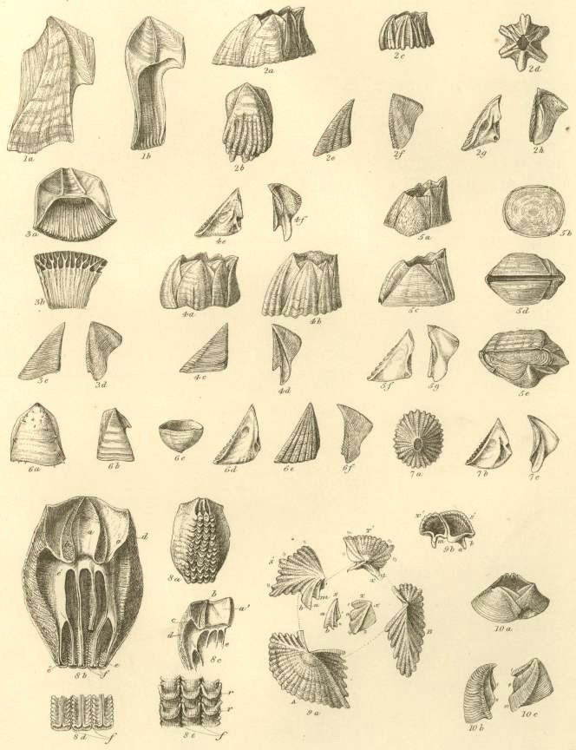
Operculum, or opercular valves. - These consist of a pair of scuta and a pair of terga. They are joined to the sheath of the shell by the opercular membrane.
Scutum (fig. 5): this valve is generally sub-triangular, and its three margins are the basal, the tergal, so called from being articulated with the tergum, and the occludent, so called from opening and shutting against the opposed valve. The angles are named from the adjoining margins, as basi-tergal, &c.; the upper angle being the apex. The scutum is ordinarily articulated to the tergum by an articular ridge (crista articularis), running up to the apex of the valve, and by an articular furrow, which latter receives the scutal margin of the tergum. The articular ridge, instead of projecting straight up from the valve, when the latter is laid flat on its external surface, often bends over to the tergal side, and is then said to be reflexed. On the internal surface of the valve, there is almost always an adductor pit or cavity (fossa adductoris), for the attachment of the adductor scutorum muscle: this pit is often bounded on its tergal and basal sides, by a ridge, called the adductor ridge (crista adductoris), which, in its upper part, is often confluent with the articular ridge. Beneath the adductor ridge, in the basi-tergal corner of the valve, there is often a lateral-depressor pit (fossa musculi lateralis depressoris), for the attachment of the so-called muscle; and this pit is sometimes furnished with crests.
Tergum, (figs. 6 and 7): this valve, also, has three margins, the scutal, basal, and carinal; its upper end, or apex, is sometimes beaked; on the basal margin a spur (calcar) depends; the outer surface of the valve is depressed or longitudinally furrowed (sulcus longitudinalis) in the line of the spur. The part called the spur is often so broad, that the name becomes not very appropriate. The angles are denominated, from the adjoining margins, as basi-carinal, or basi-scutal angle, &c. On the under side, in the upper part, there is an articular ridge, and on its scutal side, an articular furrow, receiving the articular ridge of the scutum. In the basi-carinal corner of the valve there are often crests for the attachment of the tergal depressor muscle.


Fig. 5 SCUTUM Fig.6 TERGUM (External view)
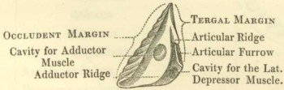

Fig. 7 TERGUM (Internal view)

